**REPORT OF THE ANALYSIS**

This report analyzes the trends in movie genre popularity from 1980 to 2020. The data is sourced from a dataset containing 30,000 movies released during this period. The goal is to identify different trends such as how the popularity of different genres has evolved over the years, seasonal trends in movie releases, rating trends, number of movies by genre and decade, and popular movie titles. Understanding these trends can provide valuable insights for filmmakers, producers, and marketers in the movie industry. Future studies could delve deeper into the factors influencing these trends, such as cultural shifts, technological advancements, and changes in audience preferences.

For the analysis and visualization of the dataset, several Python libraries are utilized. NumPy is employed for numerical computations and array operations, while Pandas facilitates data manipulation and analysis. For visual representation, Matplotlib is used to create a variety of static, animated, and interactive plots, and Seaborn is used to generate aesthetically pleasing and informative statistical graphics.

The line graph illustrates the number of movies released annually across various genres from 1980 to 2020. This data provides valuable insights into the trends within the film industry over four decades. In the sections down below, a more detailed analysis of these trends is provided and supported by additional graphs.

The line graph shows the number of movies released each year for two genres: Action (blue line) and Adventure (green line) from 1980 to 2020. These two genres were chosen for comparison because they share common elements such as heroic protagonists, recurring themes, and striking visual effects. Here are some observations and correlations:

* There are several points where the trends for both genres move in parallel. For example, both genres see an increase in releases around the early 1990s and mid-2010s. This indicates that factors influencing the production of one genre might similarly affect the other, suggesting a positive correlation between these two movie genres. However, there are also periods where the trends diverge. For instance, between 1995-2000, Action movies see a sharp increase, while Adventure movies do not show a corresponding spike. This could be due to specific blockbuster releases (e.g. The Rock (1996), Independence Day (1996), Armageddon (1998), The Matrix (1999), Gladiator (2000), Mission: Impossible 2 (2000)) or shifts in audience preferences, which can be interpreted as negative correlation.
* Both genres experience peaks and troughs at various points. Notable peaks for Action movies occur around 1990 and mid-2000s, while Adventure movies have significant peaks around 1990 and 2015. These peaks could be associated with the release of major franchise films or technological advancements in filmmaking.

The line graph shows the number of movies released each year for two genres: Comedy (purple line) and Drama (pink line) from 1980 to 2020. These two genres were chosen due to their contrasting ways of exploring human experiences which offers an intriguing comparison. Here are some observations and correlations:

* There are several points where the trends for both genres move in parallel. For example, both genres see an increase in releases around the early 1980s and early 2000s. This indicates that factors influencing the production of one genre might similarly affect the other, suggesting a positive correlation between these two movie genres, which could be, for instance, due to audience preferences.
* However, there are also periods where the trends diverge. For instance, in the early 1990s, the number of drama movies surged, while comedy movies experienced a decline. Conversely, in the late 1990s, comedy movies saw an increase as drama movies decreased. This demonstrates that while these genres have shown a positive correlation during certain periods, they also exhibited a negative correlation, with one genre increasing as the other decreased. The trend could be due to cultural shifts, with early 90s society craving intense drama, and the late 90s favoring the lighter escapism of comedy. Economic factors played a role too, as comedies are cheaper to produce. Audience preferences often shift, driven by societal moods and the success of key films. Thus, the rise and fall of drama and comedy movies reflect a dance between cultural, economic, and cinematic influences.
* Both genres experience peaks and troughs at various points. Notable peaks for Action movies occur around 1990 and mid-2000s, while Adventure movies have significant peaks around 1990 and 2015. These peaks could be associated with the release of major franchise films or technological advancements in filmmaking.

The line graph shows the number of movies released each year for two genres: Horror (black line) and Thriller (red line) from 1980 to 2020. These two genres were chosen due to both genres aiming to elicit intense emotional reactions, like fear and suspense, using similar narrative techniques and atmospheric tension. Here are some observations and correlations:

* Even though the two genres moved in parallel for most of the period, there was a significant divergence in the late 90s and early 2000s. They exhibited a negative correlation, with one genre increasing while the other showed the opposite trend. In the late 90s and early 2000s, horror movies experienced a surge due to advancements in special effects (CGI), cultural shifts towards darker themes post-9/11, and the success of key films like "The Blair Witch Project" and "Scream." Conversely, thrillers saw a decline as audience preferences leaned towards more intense experiences, and economic factors made horror a more cost-effective genre to produce.

**Seasonal Trends in Movie Releases**

The heatmap illustrates seasonal trends in movie releases across various genres. The vertical axis represents the months of the year (1 to 12), while the horizontal axis lists different movie genres. Each cell in the grid is color-coded. Lighter shades indicate fewer releases and darker shades indicate more releases.

This heatmap was created to identify any correlation between specific seasons and movie genres. Contrary to expectations, the map reveals no significant relationship between genre releases and seasons. For instance, while one might expect a rise in horror and thriller movies in autumn due to Halloween, the data shows that the peak release times for these genres are actually in January and June. Horror films are released throughout the year, not just around Halloween, for strategic reasons. January/February is less competitive, spring (March/April) targets post-winter audiences, summer offers counter-programming to blockbusters, and September captures early Halloween interest. Despite October's association with Halloween, studios often avoid it due to market saturation.

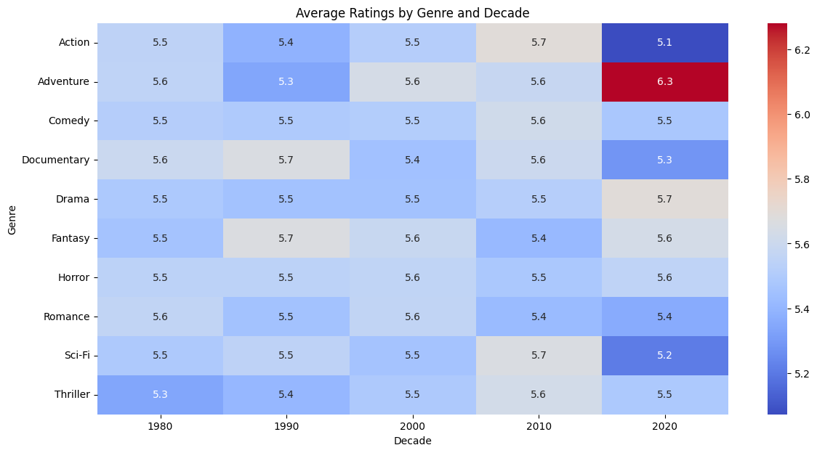

The heatmap illustrates average ratings by genre and decade. The vertical axis represents the genres, while the horizontal axis lists the decades. Each cell in the grid is color-coded. Bluer shades indicate a lower average rating, whereas redder shades indicate a higher average rating.

The only notable difference in average ratings is evident in 2020 between Action and Adventure movies. Adventure movies received higher ratings, while Action movies experienced a decline, despite both genres having a similar number of releases that year (see graph 2). This surge in Adventure movie ratings could be attributed to blockbuster hits like Wonder Woman 1984 and Mulan. However, the global pandemic likely impacted movie production and budgets, potentially contributing to the decrease in Action movie ratings.

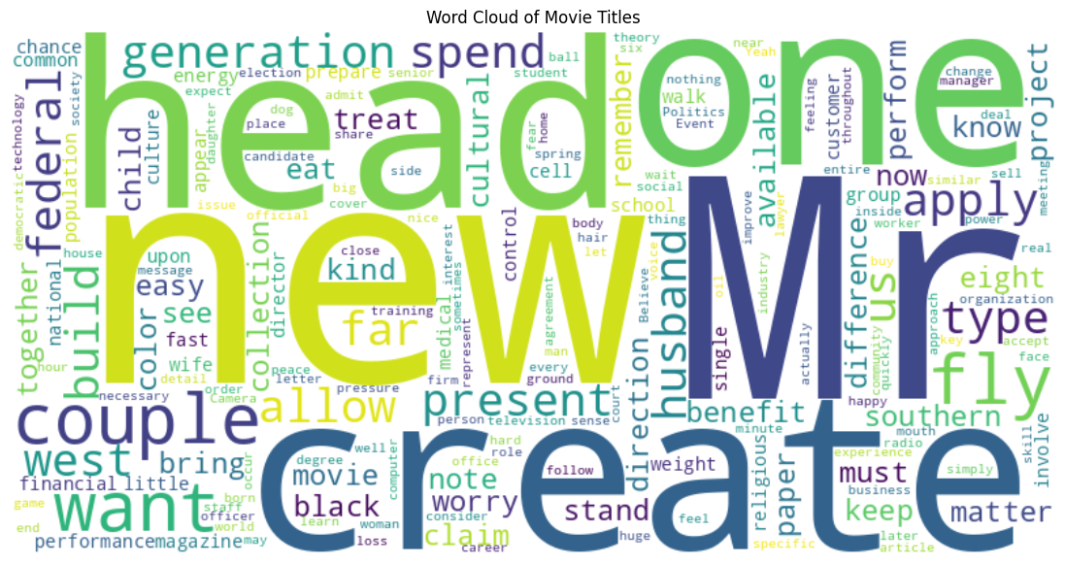

This word cloud highlights the most frequently used words in movie titles from the 1980s to 2020. A word cloud of movie titles helps quickly see common themes and trends over time by showing the most frequently used words. It offers a quick snapshot to spot patterns and insights.

Among 30k movie titles, the most frequently used words are: "Mr.," "create," "new," "one," "head," "couple," "want," and "fly."

The heatmap illustrates number of movies released by genre and decade. The vertical axis represents the genres, while the horizontal axis lists the decades. Each cell in the grid is color-coded. Bluer shades indicate a lower number of releases, whereas redder shades indicate a higher number of releases.